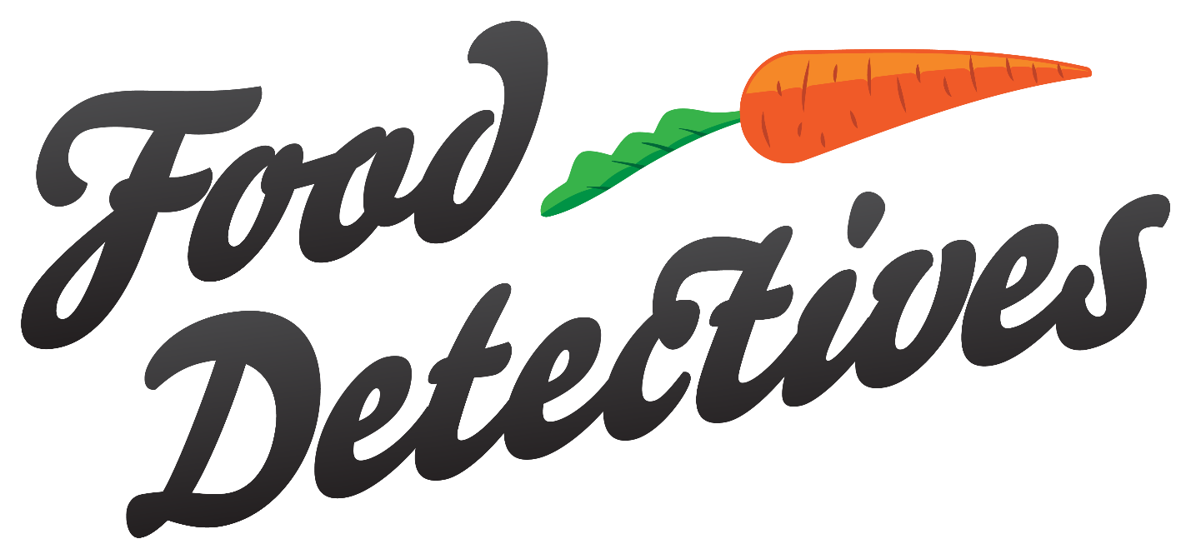

Technical Specifications

Final Project

Contents

1. Open Visual Code Studio 4

2. Create folder on Desktop for the project, then click Open folder. 4

3. Select Folder: ex Test_Folder 5

4. Inside of the folder right click and click on Open Terminal 5

5. Open Terminal on the bottom 6

6. Insert line here. 6

7. Install modules 7

8. Deploy 7

Technologies Used

1. HTML/CSS/JavaScript
2. NodeJS
3. EJS Template
4. MSSQL
5. GIT
6. Heroku (Web Hosting)

Source Code

1. GitHub

<https://github.com/BColantonio/food-detectives>

1. SQL Server Management Studio

Database: **se425_food_detectives**

user: **'detectives'**

password: **'neit2020'**

Development Environment

1. Visual Studio Code
2. SQL Server Management Studio

Deployment

1. Heroku

<https://www.heroku.com/>

Website URL

1. Heroku

<https://fooddetectives2.herokuapp.com/>

Retrieve Source Code for development

### 1. Open Visual Code Studio

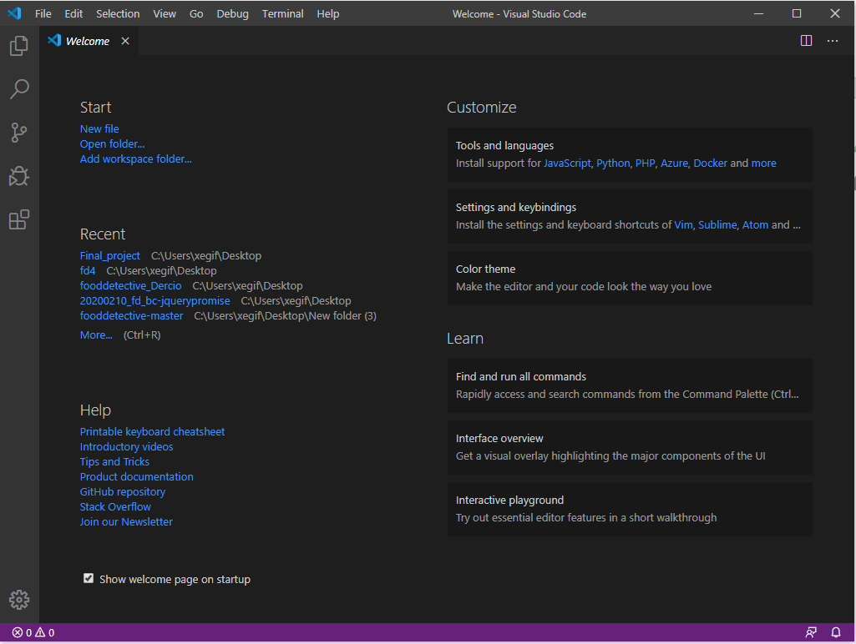

### 2. Create folder on Desktop for the project, then click Open folder.

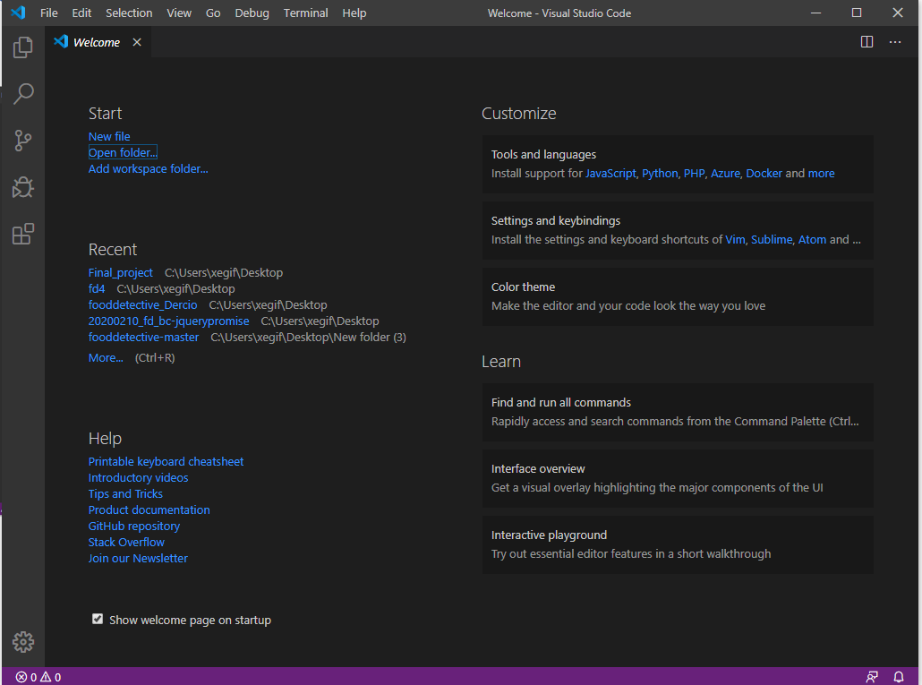

### 3. Select Folder: ex Test_Folder

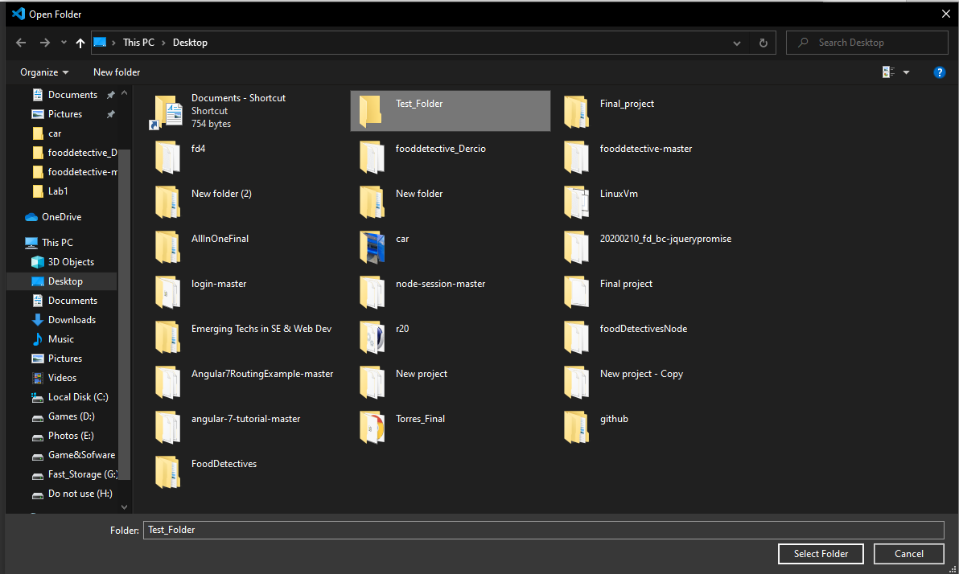

### 4. Inside of the folder right click and click on Open Terminal

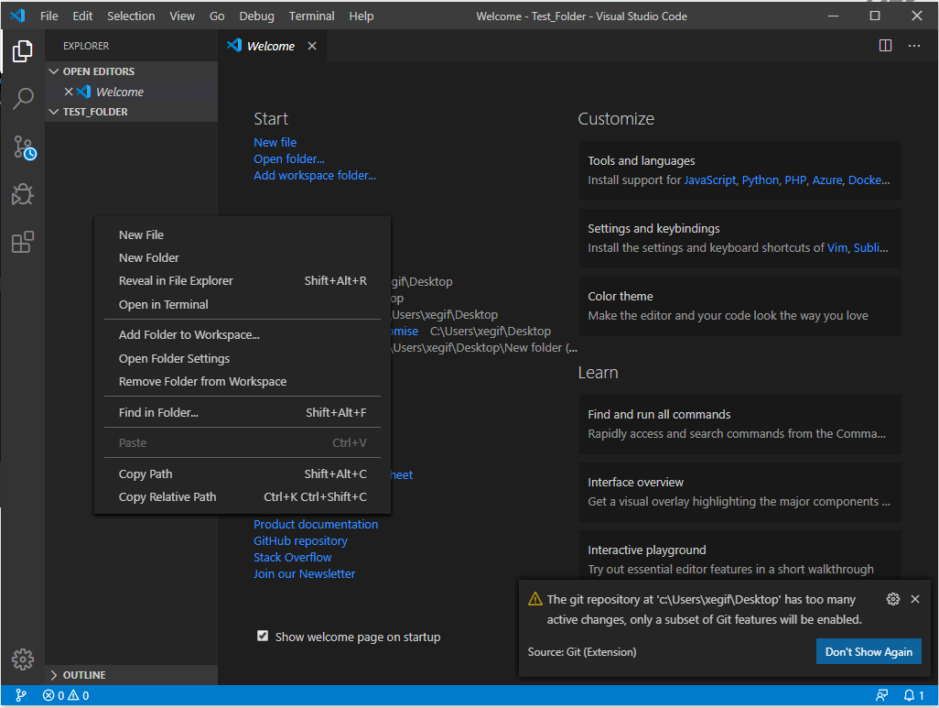

### 5. Open Terminal on the bottom

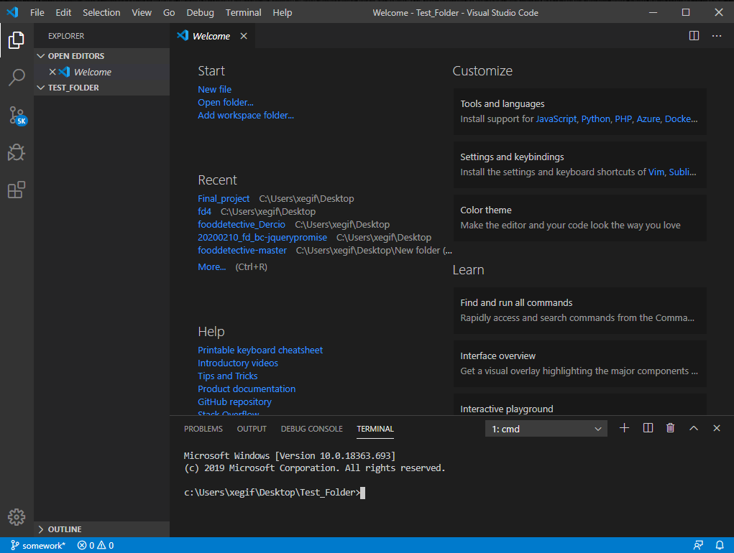

*Make sure you are inside of the folder.

### 6. Insert line here.

git clone <https://github.com/BColantonio/fooddetective.git>   
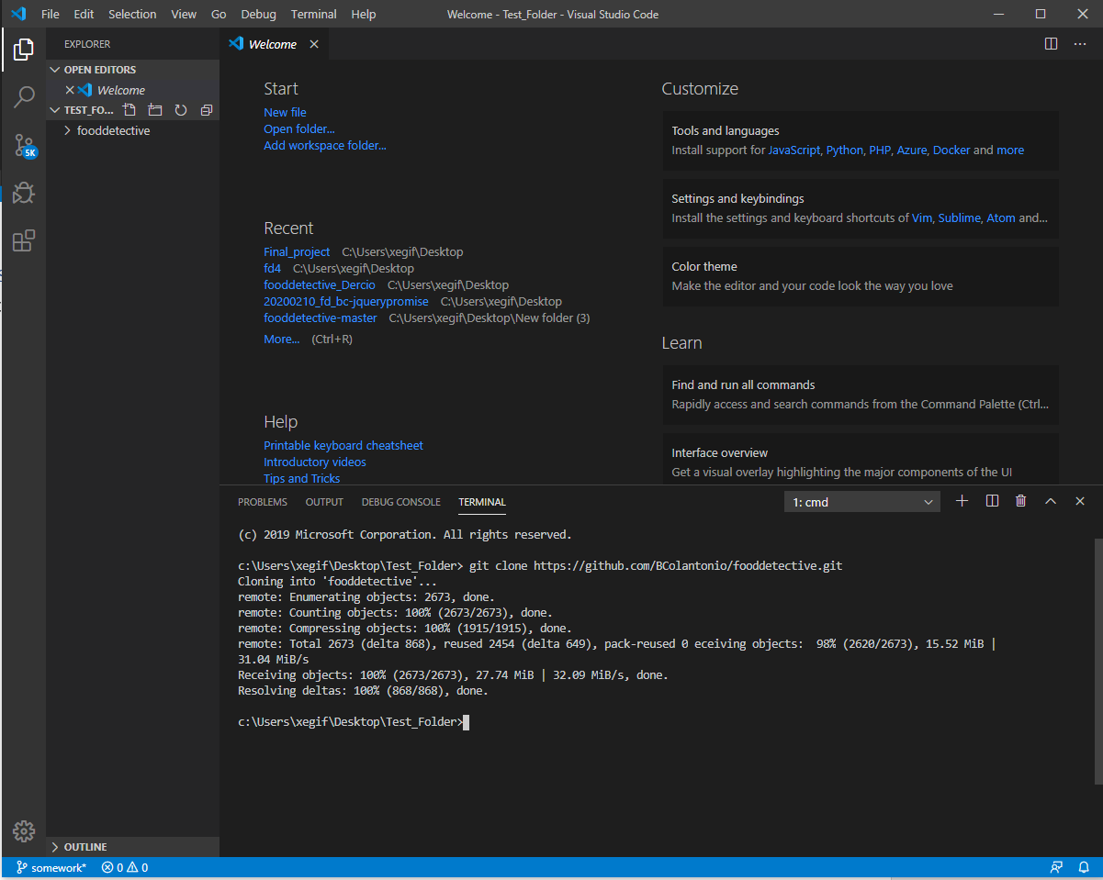

### 7. Install modules

npm install

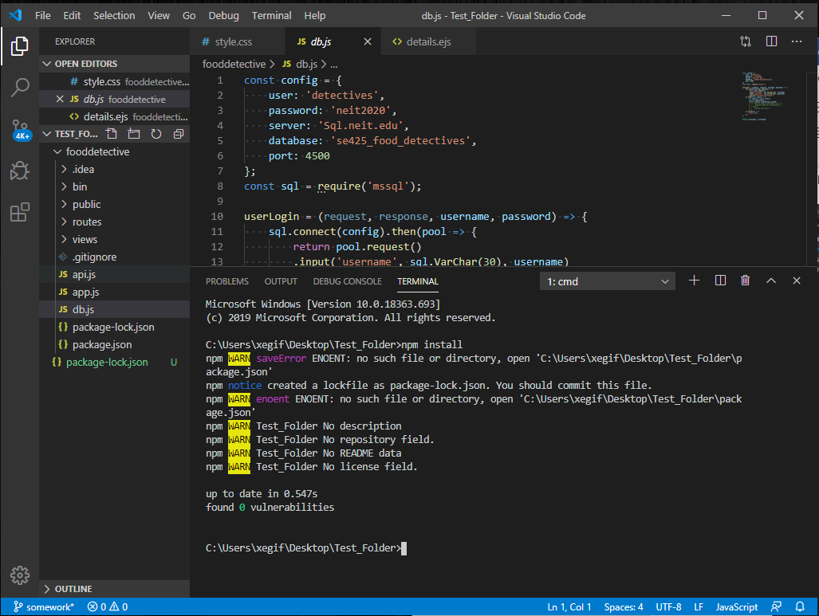

### 8. Deploy

Nodemon fooddetectives

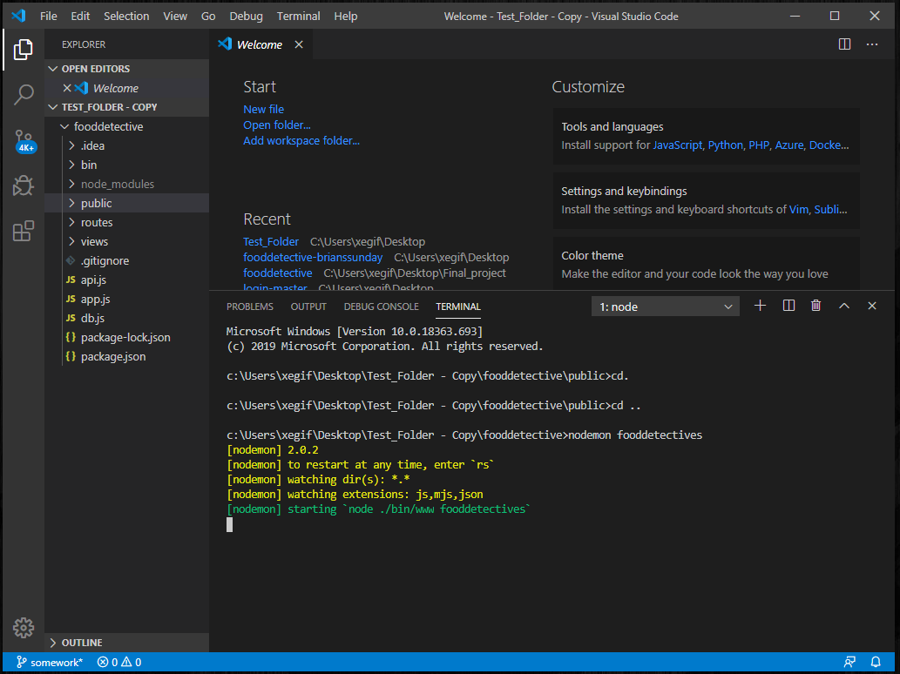

9. Run on Browser

<http://localhost:5000/>

Deploy Code

1. Push Code back to GitHub
2. Follow Heroku Deploy tutorials at:

<https://devcenter.heroku.com/articles/git>